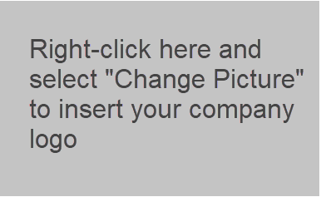
[YOUR COMPANY NAME]
[ADDRESS LINE 1]
[ADDRESS LINE 2]
[CITY, STATE]
[ZIP CODE]
[PHONE NUMBER]

6/24/2020

LETTER OF AUTHORIZATION / CARRIER FACILITIES ASSIGNMENT
This Letter of Authorization (LOA) hereby serves as authorization for the purposes of allowing PacketFabric and/or their agent to establish connectivity in the following facility:

[DATA CENTER]
[ADDRESS]
[CITY, STATE ZIP]

As such, please use the following Channel Facility Assignment:
SPEED | [PROVIDE THE SPEED YOU SELECTED FOR THE PORT]
MODE | SMF
CONNECTOR | [LC OR SC]
RACK | [ENTER RACK NUMBER, IF APPLICABLE]
PANEL | [ENTER PATCH PANEL ID, IF APPLICABLE]
PORT | [ENTER PORT POSITION]
 | [ADD/REMOVE AS NEEDED]
 | [ADD/REMOVE AS NEEDED]
 | [ADD/REMOVE AS NEEDED]

Regards,
Provisioning Team
[COMPANY NAME]

